**Charity System Based on Celo Blockchain**

Abstract.

The world's charity organizations lack transparency, and it is challenging to effectively supervise them, which has a detrimental effect on people's willingness to give. Celo A new technological solution for the charity system is offered by blockchain, which powers the Celo system. This article elaborates on the design pattern, architecture, and operational procedure of a platform for charitable giving based on blockchain technology. You may check out some of the foundational features of the giving platform on Celo in this article. By using blockchain-based charity systems, we want to improve the transparency of charities in order to strengthen the public's faith in them and foster the growth of generosity.

1. Introduction

Philanthropy has become more open and transparent as a result of the growth of Internet technology, which has increased the number of avenues by which individuals can obtain information. Numerous issues with philanthropy have come to light. The terms "Guo Meimei Incident" and "Hu Manli Incident'' were widely disseminated online. In the wake of the "5.12 Wenchuan Earthquake," some people reportedly sold tents and relief goods in exchange for cash, illustrating the complex daily administration of charitable funding and supplies. Between 2009 and 2022, these factors led to a decrease in giving intentions and a drop in donations. The public now has a new way to get involved in projects related to public welfare thanks to online crowdfunding.

The crowdfunding platform has created a database for the project, and proper project monitoring is also a crucial component of the public welfare crowdfunding platform's risk automatic management mechanism [2]. For traditional donations and online crowdfunding to gain more respect, philanthropic information must be made more transparent. Technically, the transparency of charities can be increased by establishing a traceability system using Internet technologies [3]. This proposal put out a new charity system model based on blockchain technology to achieve this goal.

2.1. Blockchain Technology

Blockchain has the ability to significantly alter established sectors because it is decentralized, impermeable, anonymous, and traceable. A distributed database system with numerous independent nodes is referred to as a blockchain. The network's nodes keep the entire database up to date. The blockchain is capable of storing all transactional data, with a clear and effective workflow and extremely secure data.

2.2. What is Celo

A blockchain system called Celo uses phone numbers as public keys and issues a native stable-value token in order to address some of the obstacles to the adoption of crypto assets (user experience and volatility). The network facilitates the creation of decentralized applications and smart contracts. Its first application, Celo Wallet, aims to create a mobile-focused social payments system. Celo and Celo Dollars are the two main cryptoassets offered by Celo. The protocol's native asset is called Celo (CELO). It functions as a utility that enables users to pay for on-chain transactions, participate in network consensus (through its Proof-of-Stake system), and vote on governance issues. A reliable asset that tracks the US Dollar is the celo dollar (cUSD).

By 2025, more than seven billion people will own smartphones, while there are now less than 0.1 billion cryptocurrency users. Useability and price stability continue to be two of the biggest barriers to bitcoin adoption, according to the Celo Foundation. The mobile-first strategy adopted by Celo tries to close this gap.

Key technological advancements that will promote adoption include:

* Quick and simple transactions (block headers optimized for fast mobile phone synchronization).
* the capability of transferring money to phone numbers (lightweight identity protocol that maps hashes of phones numbers to public keys— making it easier for anyone with a mobile phone to send and receive digital currencies to anyone in the world)
* Automatic transaction fee deducting and the choice to pay for gas in stable currencies (for as little as $0.01).
* Stable coinage, backing by a decentralized reserve, starting with cUSD, to help with stability, transparency, and auditability

2.3.Researches on blockchain Charity Platform

Liu Na [8] has examined the supervisory system of charity in China and recommended supervising charity in law, administration, industry, and society in order to strengthen the reputation of charitable organizations. The financial disclosure of Chinese charitable organizations is comparatively poor, according to Bi Ruixiang [9]. By enhancing the liability system and government oversight, Yu YuXi [10] urged limiting the influence of charitable organizations. To complete the management and promotion of charitable donations, Wang Jian and Xu Yuchao [11, 12] developed the charity donation information management system using ASP.NET technology. Through the LAMP architecture, Yang Qilin (13), who unified the management of charity foundation data and the dissemination of charity information, realized the core business system of charity fund management.

Blockchain technology has been recommended by Jia Hongwei and Deng Xiuquan [14] as a way to address issues with social emergency aid. The benefits of blockchain technology in charity were also examined and confirmed by Wang Jia and Chen Haifeng [15] in their analysis of the use of blockchain technology in China's philanthropy. Li Qi, Li Wei, and others developed the charity application platform based on the Bubi blockchain and provided the application model for the platform. In order to implement both online and offline bitcoin transactions, Danushka Jayasinghe et al. [18] established a platform for Bitcoin charity based on blockchain. This platform offers a secure and practical approach to donate to challenging regions without Internet via GSM network. We presented a new charity system using blockchain technology based on these results.

3. The Design of Charity System Based on Celo Blockchain

3.1. Charity System Mode

The charity system model proposed is shown in Figure 2. There are four roles: donors, beneficiaries, charity organizations and cooperative stores. The charity organizations get

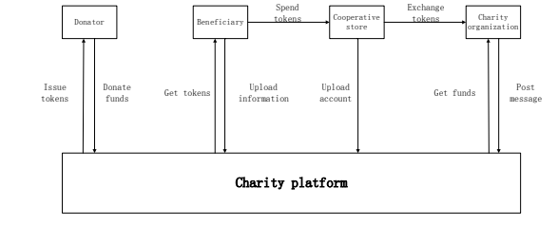

Figure 2. Proposed mode.

the information to seek help and create charity projects through the platform. Donors learn about charity projects on the platform, then donate Celo to beneficiaries or the charity organizations. Beneficiaries upload their information to the platform for help, they can get and spend tokens in cooperative stores. The transactions occurring in the stores will be uploaded to the charity platform. The cooperative stores supply services or goods to the beneficiaries to obtain tokens. The tokens can be exchanged for real money by charity organizations.The flow of funds has been fully recorded on the blockchain, which allows transactions to be tracked and funds prevented from being abused.

3.2. Proposed Platform Architecture

As depicted in Figure 3, we divide the platform into four tiers. The application service layer contains a number of apps, such as account registration, posting charity information, donating money, and sending messages for inquiries, and it gives users access to the platform's features directly. Various scripts and smart contracts are part of the smart contract layer. It includes the transaction process, query techniques, and other information. The charity platform's distributed accounting features, such as package blocks, get consensus on transactions, broadcast blocks, and synchronize data to local databases, are implemented via the blockchain service layer. Data is kept in the storage layer, which also includes local storage and blockchain storage.

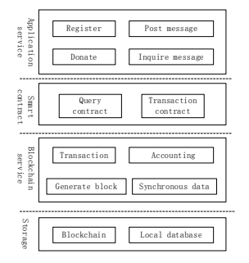

Figure 3.0

3.3. Platform Usage Process

Figure 4 shows partial operation of the charity platform, as follows:

1.Donor

The donor browses the charity projects after successfully logging in, then chooses one to donate to. The donor account's balance will be verified by the system. The user will be reminded to make a deposit if the balance is insufficient. Only when there is enough money in the account can a donation be made.

2. Those in want

The individuals who require assistance should complete the rescue information, which will be uploaded to the charitable organization for review, and the projects that have been authorized will be placed on the charitable platform. The recipient can check the account balance to see how the project is progressing, and can subsequently use the tokens to pay for goods or services at cooperative businesses.

3.Cooperative shops

The shops provide the corresponding services or goods such as medicines or books to the beneficiaries to obtain tokens.they can exchange tokens for real money by charity organizations.

4.Charity organization

The organization can get donations from the platform to help other people and apply money to the cooperative shops for token exchanging.

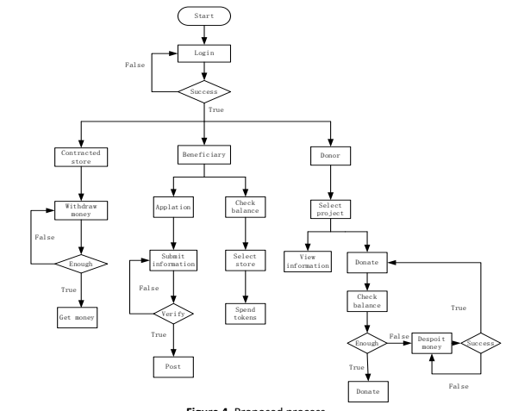

Figure 4.0

4.0 The Development Of System

In order to validate the system and show off some key features of the charity platform, I suggested creating a Dapp for a charity fundraising that is based on CELO. Our solution can be tested using Celo Wallet, and smart contracts can be created using Solidity. The Dapp will verify the operations of starting projects, giving, approving funds, and transferring funds.

4.1. Dapp Model

The timing diagram of the Dapp is shown in Figure 5. Following functions have been met: 1. Beneficiary initiates a charity project in the DApp.

2. Beneficiary requests funds from the charity project initiated by himself.

3. Donor donates to the charity projects which he chooses.

4. Donors are able to vote on the funding request for the charity project already participated.

5. After the request for funds is approved, the funds are automatically transferred to the beneficiary's account.

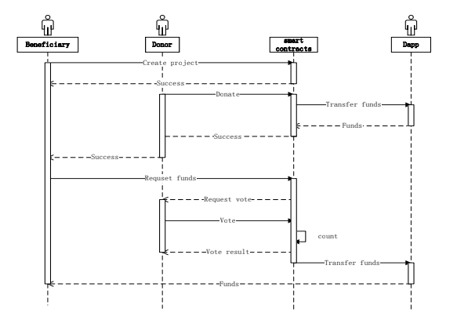

Figure 5. Dapp Timing diagram

Through a smart contract, a beneficiary starts a charitable project, which is then implemented on the blockchain. Donors browse the charity projects and choose the one they want to donate to. The Dapp administrator account will receive the cash. The capital expenditure request is started by the smart contract when the recipient requires money. The project's donation monies will be moved from the Dapp administrator account to the beneficiary account if the majority of participants who vote approve the request.

4.2. Build Smart Contracts

Value streams depending on specific terms and conditions are known as smart contracts. Smart contracts are entirely digital, unlike real contracts; they are pre-programmed pieces of code that are stored on the blockchain [20]. Similar to the blockchain, which can operate in any network node, smart contracts adapt well to the decentralization of the blockchain. Without the assistance of management, the smart contract transactions will be stored on the blockchain. The smart contract will automatically execute once the necessary conditions are satisfied. For charity platforms, transaction logic can be defined using smart contracts.

In the Dapp, we have built smart contracts to meet the functions described in the previous section, smart contracts structure is shown in Figure 6. Users can create a charity project using The ProjectList Contract which also supplies the view of all projects recorded on the blockchain. The Project contract is used to describe and store specific charity projects, which provides an interface to operate the charity project and its funds. The structure of tokens expenditures is designed separately.

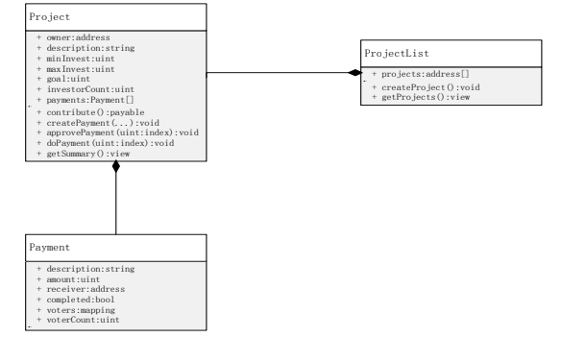

Figure 6. Dapp smart contract structure

4.3. Dapp Test

We’ll use the CeloDollar that is provided by CELO to test the DApp

The accounts provided by Celo Wallet are shown in Table 1:

Table 1. Test accounts.

Accounts Account Addresses Balance (CeloDollar)

Creator A 0x8D6677192144292870907E3Fa8A5527fE55A7ff6 10

Donor B 0x07F007d389883622Ef8D4d347b3f78007f28d8b7 10

Donor C 0xE383394B913d7302c49F794C7d3243c429d53D1d 10

Donor D 0xF26eD7d00689D384A30264B39aF82E363907A6ef 20

Beneficiary E 0xD304c675aeA12aE922c19260Ab28198B615CA3bd 0

We initiated a charity project named TestProject in the Dapp as a test.The charity project information is shown in Table 2.

Table 2. Charity project TestProject.

| Attributes | Values |
| --- | --- |
| Creator | Creator A |
| Description | Charity project TestProject |
| MinDonation | 1 CeloDollar |
| MaxDonation | 10 CeloDollar |
| Goal | 100 CeloDollar |
| Receiver | Beneficiary E |
|  |  |

Table 2.0

Then we take different accounts into the TestProject, different donors donate to the project with different amounts to make the test.Table 3 shows the test results of different donation amounts.

| Donor | Amount CeloDollar | Message | Remarks |
| --- | --- | --- | --- |
| Donor B | 0 | Fail | Invalid number |
| Donor B | 0.1 | Fail | Less than minimum |
| Donor B | 1 | Success | - |
| Donor C | 5 | Success | - |
| Donor D | 20 | Fail | Exceeding the maximum |

Table 3. Donation tests.

When the donation has been finished, the beneficiary created some different token requests to test the function of funds transfer.Table 4 shows the process details.

Table 4. Request for Funds test By Beneficiary E.

| Account | Amount CeloDollar | Message | Remarks |
| --- | --- | --- | --- |
| Beneficiary E | 0 | Fail | Invalid number |
| Beneficiary E | 100 | Fail | Exceeding the maximum |
| Beneficiary E | 99 | Success | - |

The test results show that our DApp has achieved some of the core functions of the charity platform proposed in this paper.

5. Conclusion

I researched how Celo Blockchain technology and philanthropy could work together, and I proposed a brand-new charity platform model based on blockchain. Users in this system complete the donation and make use of the money through smart contracts. To achieve financial traceability and promote charity transparency, all transactions are tracked on the blockchain. With this blockchain-based charity system, the technological problem of lack of transparency in charitable activities might be resolved, which might lead to a rise in public confidence in charitable organizations. A Dapp I proposed has realized and verified some of the fundamental elements. Our next step is to implement a full blockchain-based charity system.

6. References

[1] Sun Xiaoshu, A Brief Analysis of 2012 China Charity Donation Data, China Development Brief, 2013(4).

[2] Ke Xiang, Analysis on the Operation of Internet Public Welfare Crowdfunding Platform and Its Risk Control Mechanism, Hainan Finance, 2016(11)64-68+83.

[3] Zhang Peng, Li Ping, Zhao Wenbo, Resolving the Dilemma of Charity and Credibility: The Theory and Evidence of the Application of Traceability System Principles, Social Sciences Research, 2016(03)40-46.

[4] Nakamoto S, Bitcoin:A peer-to-peer electronic cash system, https://bitcoin.org/bitcoin.pdf.2017. [5] Zheng, Z,Xie, S,Dai, H,Chen, X, Wang, H,An Overview of Blockchain Technology: Architecture,Consensus,and Future Trends. Proceedings of the 2017 IEEE International Congress on Big Data(BigData Congress), Honolulu, HI, USA, 25-30 June 2017. IEEE: Piscataway, NJ, USA, 2017, pp. 557–564.

[6] Cai Weide, Yu Lian, Wang Rong, Liu Na, Deng Enyan, Research on Application System Development Method Based on Blockchain, Journal of Software, 2017, 28(06)1474-1487. [7] Shao Qifeng, Jin Cheqing, Zhang Zhao, Qian Weining, Zhou Aoying, Blockchain Technology: Architecture and Progress,Chinese Journal of Computers, 2018, 41(05)969-988. [8] Liu Na, Research on the Supervision System of Chinese Philanthropy, Social Sciences, 2016, 31(06)49-52.

[9] Bi Ruixiang, Discovery and Improvement of Financial Information Disclosure of Charitable Organizations in China, Local Finance Research, 2017(05)92-97.

[10] Xiang Yuxi, Research on Property Use Limitation of Charity Foundation, Southwest University of Political Science and Law, 2017.

[11] Wang Jian, Design and implementation of charitable donation information management system, University of Electronic Science and Technology of China, 2013.

[12] Xu Yuchao, Design and implementation of charitable donation system based on ASP.NET, Dalian University of Technology, 2017.

[13] Yang Yulin, Design and Implementation of Core Business System for Charity Fund Management, Hunan University, 2017.

[14] Hong-wei JIA, Xiu-quan DENG, A Preliminary Analysis of the Application of Blockchain in Social Emergency Relief, Proceedings of 2018 2nd International Conference on Education, Management and Applied Social Science(EMASS 2018), doi: 10.12783/dtssehs/emass2018/20436.

[15] Wang Jia, Chen Haifeng, Application Analysis and Research of Blockchain Technology in China's Philanthropy, Computer and Information Technology, 2017(6).

[16] Li Qi, Li Wei, Zhu Jianming, Guan Xiaoyao, Wang Hui, et al. Charity application model and platform based on blockchain technology, Journal of Computer Applications, 2017(A2).

9

SAMSE 2019

IOP Publishing

IOP Conf. Series: Materials Science and Engineering 768 (2020) 072020

doi:10.1088/1757-899X/768/7/072020

[17] Rizal Mohd Nor, M.M Hafizur Rahman, Towfiqur Rahman, Adam Abdullah. (2017)Blockchain sadaqa mechanism for disaster aid crowd funding in Zulikha, J. & N. H. Zakaria (Eds.), Proceedings of the 6th International Conference of Computing & Informatics, pp. 400-405.

[18] Jayasinghe D., Cobourne S., Markantonakis K., Akram R.N., Mayes K. (2018) [19] Philanthropy on the Blockchain. In: Hancke G., Damiani E. (eds) Information Security Theory and Practice, WISTP 2017, Lecture Notes in Computer Science, vol 10741.

[20] Shao Qifeng, Jin Cheqing, Zhang Zhao, Qian Weining, Zhou Aoying. Blockchain Technology: Architecture and Progress, Chinese Journal of Computers, 2018(5).

[21] Daniel Macrinici, Cristian Cartofeanu, Shang Gao.Smart contract applications within blockchain technology: A systematic mapping study,Telematics and Informatics.Volume 35, Issue 8, 2018, pp. 2337-2354.

10